A

PROJECT REPORT

ON

**“****INSURANCE MANAGEMENT SYSTEM ”**

Towards partial fulfilment of the requirement in

**6th Semester BCA (2022-23)**

**Submitted by:**

Aman Kumar Singh (200510101159)

Roshani Singh (200510101164)

**Submitted To:-**



**Parul Institute of Computer Application,**

**Parul University.**

Under the guidance of

Assistant Professor

**Vibhuti Patel**

**Acknowledgement**

*The success and final outcome of this project required a lot of guidance and assistance from many people and we are extremely privileged to have got this all along the completion of our project. All that we have done is only due to such supervision and assistance and we would not forget to thank them.*

*We respect and thank Dr. Priya Swaminarayan, Dean, FITCS for providing us an opportunity to do the project work in BCA and giving us all support and guidance, which made us complete the project duly. We are extremely thankful to Mam for providing her support and guidance, although she had busy schedule managing the academic affairs.*

*We would not forget to remember Dr. Hina Chokshi, HOD, BCA department for her encouragement and more over for her timely support and guidance till the completion of our project work.*

*We owe our deep gratitude to our project guide Vibhuti Patel, who took keen interest on our project work and guided us all along, till the completion of our project work by providing all the necessary information for developing a good system.*

*We are thankful to and fortunate enough to get constant encouragement, support and guidance from our Parents, all Teaching staffs of BCA Department which helped us in successfully completing our project work. Also, we would like to extend our sincere esteems to all staff in laboratory for their timely support.*

***[Aman Kumar Singh] [200510101036]***

***[Roshani Singh] [200510101164]***



PARUL INSTITUTE OF COMPUTER APPLICATION

**CERTIFICATE**

This is to certify that **Aman Kumar Singh and Roshani Singh** the students of Parul Institute of Computer Application, has/have satisfactorily completed the project entitled “**Insurance Management System***”* as a part of course curriculum in BCA semester-VI for the academic year 2022-2023 under guidance of **Prof. Vibhuti Patel*.***

Enrollment Number: 200510101159

Enrollment Number: 200510101164

|  |  |  |
| --- | --- | --- |
| **Quality of work** | **Grade** | **Sign of Internal guide** |
| **Poor /Average / Good /**  **Excellent** | **B /B+ / A / A+** |  |

Date of submission:

HOD, Principal,

**Dr Hina Chokshi** **Dr Priya Swaminarayan**

**INDEX**

INDEX OF FIGURES 6

1. Company Profile 7

2. Project Profile 8

• Insurance Management System 8

• Existing System and Problem Statement 8

• Need for new system and Purposed System 9

• Scope 9

• Tools & Technology used with short justification 9

3. Requirement Analysis 10

• Feasibility Study 10

➢ Technical Feasibility 10

➢ Economic Feasibility 10

➢ Operational Feasibility 10

➢ Importance of Feasibility Studies 11

➢ Feasibility Study of our Proposed System 11

Technical Feasibility: 11

Economical Feasibility: 11

Operational Feasibility: 11

• Users of the system 11

• Admin 11

• Customer 11

• Modules of the system 11

• Description of Modules 12

• Hardware Requirements (Developer) 13

• Software Requirements (Developer) 13

• Hardware Requirements (User) 13

• Software Requirements (User) 13

4. Design 14

• Use Case Diagram 14

• DFD (Data Flow Diagram) 15

• Entity Relation 19

• Flow Chart 20

• Activity Diagram 21

5. Data Dictionary 23

6. Implementation 26

7. Testing 31

7.1 Test Strategy 31

TEST CASE: 32

Future Enhancements 34

Reference and Bibliography 35

# INDEX OF FIGURES

Figure 1: Use Case diagram for Admin 24

Figure 2: Use Case diagram for Customer 25

Figure 3: Context Level DFD of Insurance Management system 25

Figure 4: Level 1 DFD of Insurance Management System 26

Figure 5: Level 1 DFD of Insurance Management System 27

Figure 6: Level 2 DFD of Insurance Management System 27

Figure 7: Level 2 DFD of Insurance Management System 28

Figure 8: Level 2 DFD of Insurance Management System 28

Figure 9: Level 2 DFD of Insurance Management System 29

Figure 10: Entity Relationship Diagram 29

Figure 11:FlowChart Diagram of Insurance Management System 30

Figure12: Activity Diagram of Insurance Management System 31

Figure13: Activity Diagram of Insurance Management System 32

Figure 14: Homepage 36

Figure 15: Login 36

Figure16: Registration 37

Figure17: About Us 37

Figure18: Admin Dashboard 38

Figure19: Customer Dashboard 38

Figure20: Add Policy 39

Figure21: Update Customer 39

Figure22: Apply for Insurance Policy 40

Figure23: View/Response Tickets 40

# Company Profile

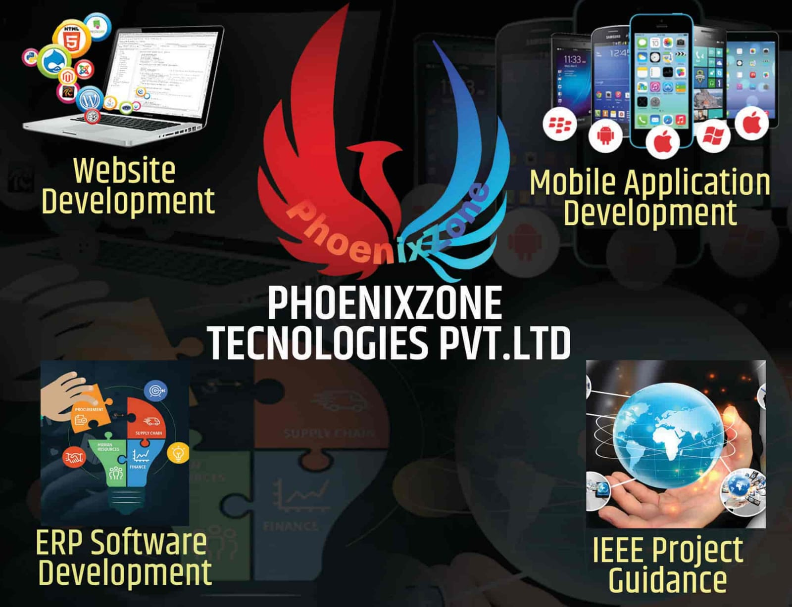

**About Us**

* PhoenixZone Technologies Private Limited is leading technology service provider and software development company delivering best quality software’s and application development, rich internet technologies and digital marketing. Our teams of qualified professionals assure you of 100% success.

**Services**

* Website Designing / Development
* Mobile Application Development
* Customize Software

1st Floor, Above Ideal Academy, Sagar Park Lane No. 3, Near Tata Guard Room BRT Stop & Sarvodaya Hotel, Sunita Nagar, Wadgaon Sheri, **Pune**, Maharashtra 411014.

**Website:**[**www.thephoenixzone.com**](http://www.thephoenixzone.com/) **Email:**thephoenixzone@gmail.com

# Project Profile

## Insurance Management System

This Insurance Management System is created for the betterment and ease for Insurance related services for both the Customers and Insurance provider Companies. There will be only two types of users in this System, Superuser (also known as Admin) are responsible for every activity which will be performed in this system, they can manage all the users and systems functionalities.   
The other user of this system will be Customer who wants to buy and insurance service or they already having any Insurance Service.

This Website is an Online micro insurance analysis and information management system, that provides easy access of information regarding the people and resources of insurance. This site is not a static site but with wonderful dynamic facilities like search tools for insurance awareness article, guidelines, illustrations through images for visitors. This site also provides several dynamic features like auto provide suggestions to users about which insurance should they have to purchase and also provide detailed information about every insurance services. It also shows the detailed comparison between insurance. There will be also recommendation feature is in the system which will notify user about all new insurance services which will be introduces in the Market.

## Existing System and Problem Statement

* Today’s majority of website is made using PHP and .Net, however they lack in performance for Real-time application.
* Face issue in scalability for modern application.
* Dealing with payment process can be time consuming and less secure.
* Lack of security authentication.

## Need for new system and Purposed System

* Scalability. A key feature of Node.js which helps to outperform other platforms in scalability. Because this JavaScript environment manages scalability and adapts it to your business needs, this platform ensures substantial growth of your e-commerce store.
* Ensuring a Hassle-Free Payment System, Keeping Track of Your Stock, Ensuring Smooth Shipping Experience, A Simple UI/UX ...
* High-performance for Real-time Applications.

## Scope

* An online store is a virtual store on the Internet where customer can browse the catalogue and select product of interest. The selected item may be collected in a shopping cart. At checkout time, the item in the shopping cart will be presented as an order. At that time, more information will be needed to complete the transaction. Usually, the customer will be asked to fill or select a billing address and payment option such as PayPal or Cash on Delivery. An e-mail notification is sent to the customer as soon as the order is placed.

## Tools & Technology used with short justification

* PHP Stands for hypertext pre preprocessor, PHP is general-purpose scripting language geared toward web development.
* Codeignitor is a powerful framework with a very small footprint, built for developers who need a simple and elegant toolkit to create full-featured web applications.

# Requirement Analysis

## Feasibility Study

As the name implies, a feasibility analysis is used to determine the viability of an idea, such as ensuring a project is legally and technically feasible as well as economically justifiable. It tells us whether a project is worth the investment—in some cases, a project may not be doable. There can be many reasons for this, including requiring too many resources, which not only prevents those resources from performing other tasks but also may cost more than an organization would earn back by taking on a project that isn’t profitable.

A well-designed study should offer a historical background of the business or project, such as a description of the product or service, accounting statements, details of operations and management, marketing research and policies, financial data, legal requirements, and tax obligations. Generally, such studies precede technical development and project implementation.

## Technical Feasibility

This assessment focuses on the technical resources available to the organization. It helps organizations determine whether the technical resources meet capacity and whether the technical team is capable of converting the ideas into working systems. Technical feasibility also involves the evaluation of the hardware, software, and other technical requirements of the proposed system. As an exaggerated example, an organization wouldn’t want to try to put Star Trek’s transporters in their building—currently, this project is not technically feasible.

## Economic Feasibility

This assessment typically involves a cost/ benefits analysis of the project, helping organizations determine the viability, cost, and benefits associated with a project before financial resources are allocated. It also serves as an independent project assessment and enhances project credibility—helping decision-makers determine the positive economic benefits to the organization that the proposed project will provide.

## Operational Feasibility

Determine the viability, cost, and benefits associated with a project before financial resources are allocated. It also serves as an independent project assessment and enhances project credibility—helping decision-makers determine the positive economic benefits to the organization that the proposed project will provide.

## Importance of Feasibility Studies

A feasibility study is conducted to determine the success and minimize the risks related to the project. It is not merely project research, but a framework or a plan on how to establish and run a business successfully in the long run. It contains five essential components, including market research, financial research, management research, schedule determination, and technical research.

## Feasibility Study of our Proposed System

### Technical Feasibility:

* In this proposed system, technical feasibility depends on open-source tools and technologies.
* In this system technologies like PHP, CI Framework, HTML, CSS, JavaScript, MySQL, Bootstrap, and Canvas are used.

### Economical Feasibility:

* Development Costs:

The system is economically feasible as its costs nothing because all depend on open source.

* Production Costs**:**

Operation, and maintenance cost including software and hardware upgrading.

### Operational Feasibility:

* The main purpose of the proposed system is that it will provide the ease to insurance providers company and the insurance customers.
* Users can easily purchase any type of insurance which is provided by the System with easily renewal.
* This system will able to support of type of insurance related services and also help the customers to solve their all issues.
* The system will work on managing insurance services.

## Users of the system

### Admin

Admin can manage all the Modules of the System, and they can also manage the Customers and their Policy.

### Customer

Through this website Customers can have all the facilities which he can apply/upgrade their policy and many more.

## Modules of the system

* Login/Registration
* Insurance Category
* Insurance Sub-Category
* Insurance Policy
* User Details
* Policy Holder
* Tickets

## Description of Modules

* **Login/Registration**

To login in this System, there is registration feature, after that any user can access this system, and customers can register to this system and after registration customers have to verify their profile to use system features. This System having a login user-name and password for users and every login detail can tracked by user, so its login is very secure.

* **Insurance Category**

Basically, there are two types of Insurance in this System, General Insurance and Life Insurance. These will be in this module. Admin can also add multiple Insurance Category like Car Insurance, Accessory Insurance and much more.

* **Insurance Sub-Category**

Insurance Subcategory is dependent on Insurance Category and it contains, insurance services like Health Insurance, Car Insurance, Term Insurance, Children Insurance etc, also Admin can add much more sub- categories based on the Insurance Category.

* **Insurance Policy**

Insurance policy contains the contract details between insurance company and customers. It also contains details about the renewal services.

* **User Details**

This module contains all the details about the users and their enrolled insurance services. Admin have only the access to view all the Customer Details and Admin can also update and delete it.

* **Policy Holder**

Admin having the access to view all Policy Holders who has applied for the Insurace Policy and all the status of the Policy accepted or rejected.

* **Ticket**

Ticket can be raised by Customers regarding the problem they facing and Admin will manage Tickets, Admin can response on the Customer Ticket and if the issue is resolved Admin can close the Ticket.

## Hardware Requirements (Developer)

|  |  |
| --- | --- |
| **Name of Components** | **Specification** |
| Processor | Intel Core i3 or above |
| RAM | 8GB/12GB |
| Hard Disk | 512GB/1TB |

Table 1: Developer: Hardware Requirements

## Software Requirements (Developer)

|  |  |
| --- | --- |
| **Name of Components** | **Specification** |
| Operating System | Windows 8,9,10 |
| Software development Kit | Visual Studio Code |
| Tools & languages | Xampp , Visual studio Code |

Table 2: Developer : Software Requirements

## Hardware Requirements (User)

|  |  |
| --- | --- |
| **Name of Components** | **Specification** |
| Processor | Intel / Ryzen |
| RAM | 4GB |
| Hard Disk | 1 GB |

## 

Table 3: User: Hardware Requirements

## Software Requirements (User)

|  |  |
| --- | --- |
| **Name of Components** | **Specification** |
| Operating System | Windows 8,9,10, Android, IOS, MAC, Linux |
| Basic Need/ Requirements | Internet Access |
| Tools | Chrome, MS Edge, Safari, Brave etc. |

Table 4: User: Software Requirements

# 4. Design

## Use Case Diagram

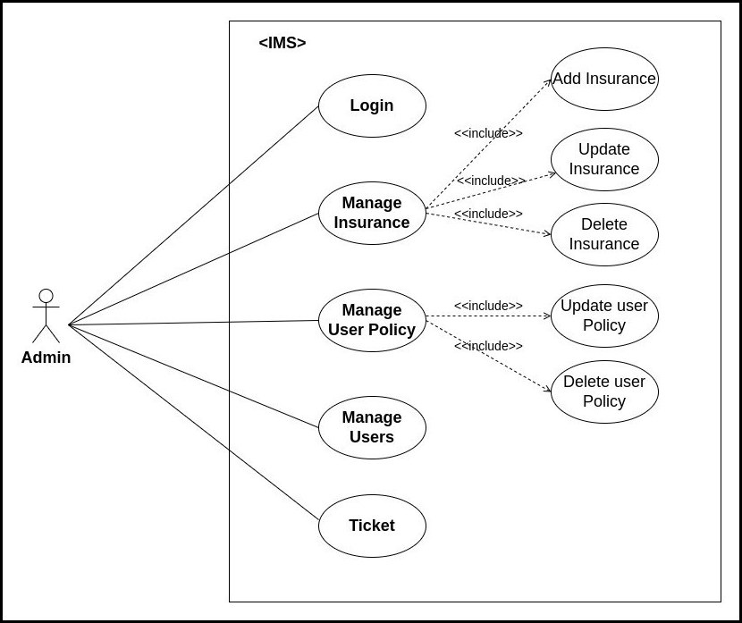

Figure 1: Use Case diagram for Admin

**Description**: It shows the interaction of the Admin and the Modules of the system.

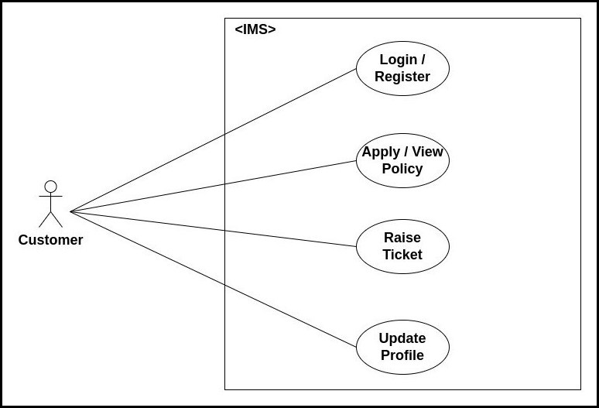

Figure 2: Use Case diagram for Customer

**Description**: It shows the interaction of the Customer and the Modules of the system.

## DFD (Data Flow Diagram)

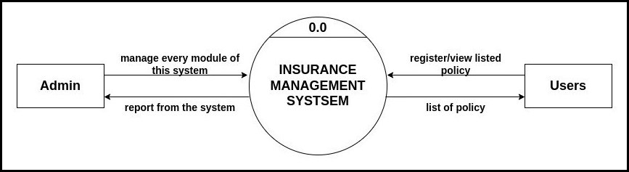

Figure 3: Context Level DFD of Insurance Management system

**Description**: DFD 0: this above diagram describe our system main activity or process.

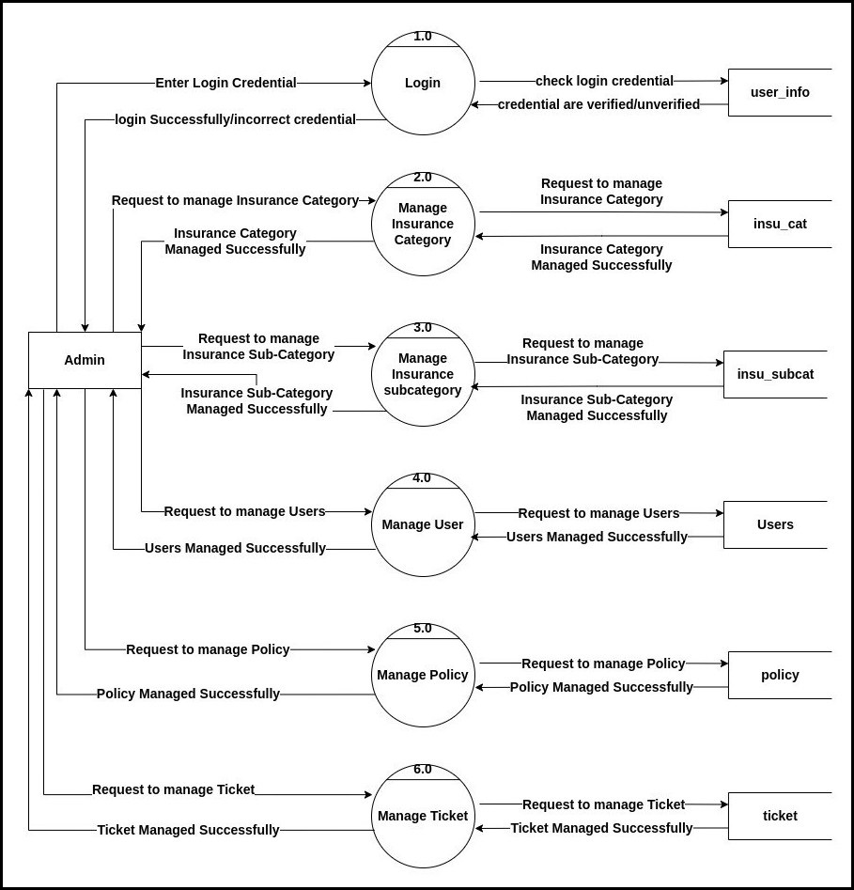

Figure 4: Level 1 DFD of Insurance Management System

**Description:** DFD 1: this above diagram describes what an admin can do.

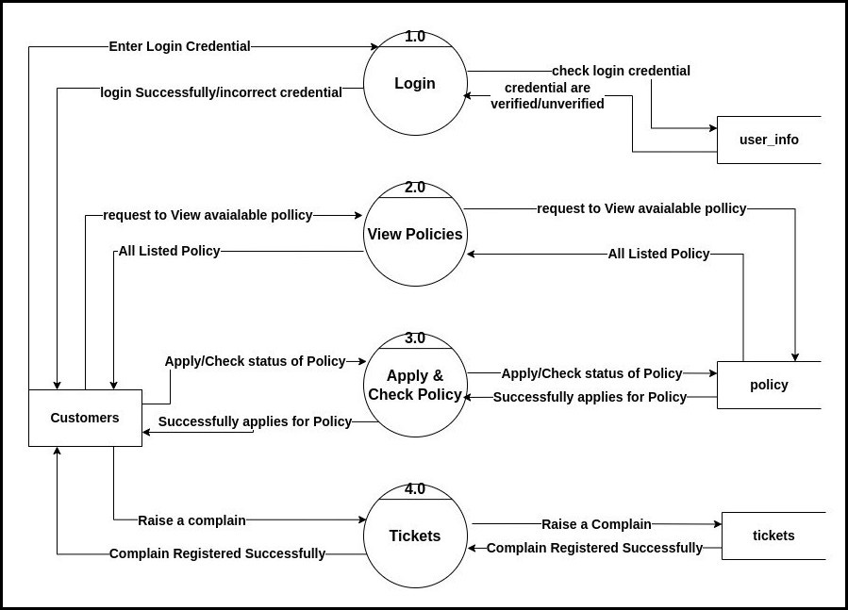

Figure 5: Level 1 DFD of Insurance Management System

**Description:** DFD 1: this above diagram describes what an Customer can do.

Figure 6: Level 2 DFD of Insurance Management System

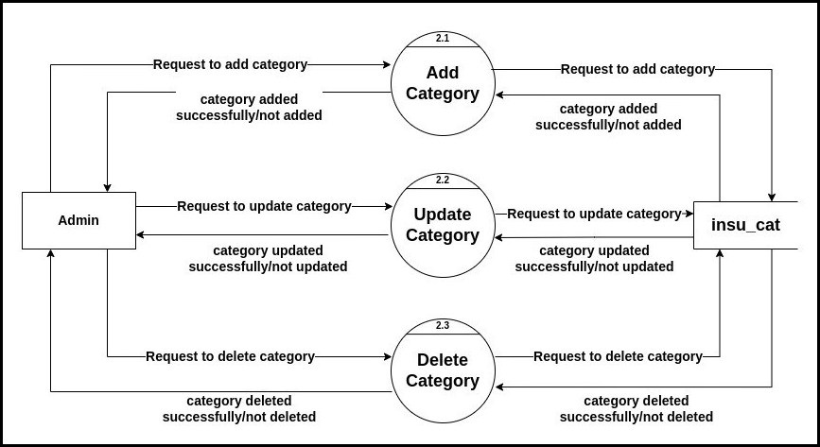

**Description :** This above diagram describes about Admin manage Categories.

Figure 7: Level 2 DFD of Insurance Management System

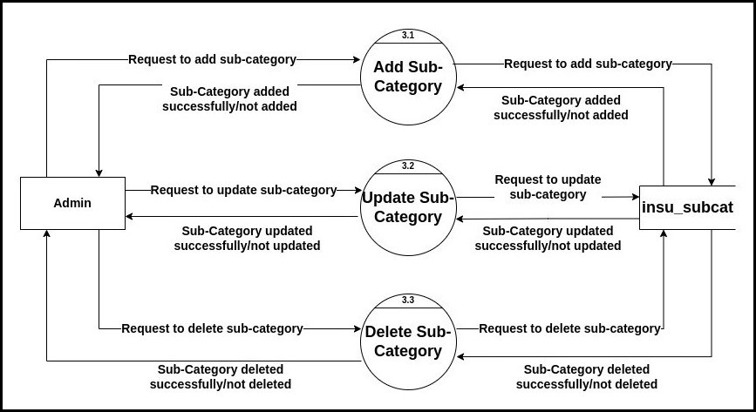

**Description :** This above diagram describes about Admin manage Sub-Categories.

Figure 8: Level 2 DFD of Insurance Management System

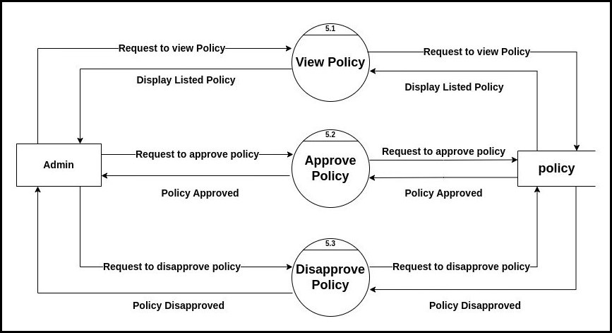

**Description :** This above diagram describes about Admin manage Policy Holder.

Figure 9: Level 2 DFD of Insurance Management System

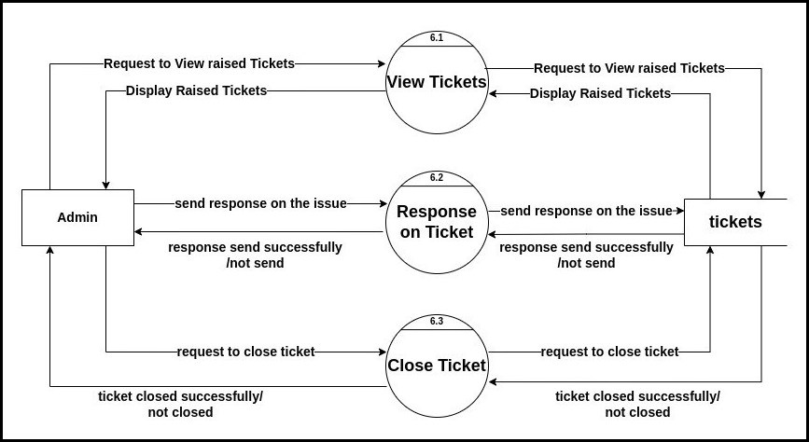

**Description :** This above diagram describes about Admin manage Ticket.

## Entity Relation

Figure 10: Entity Relationship Diagram

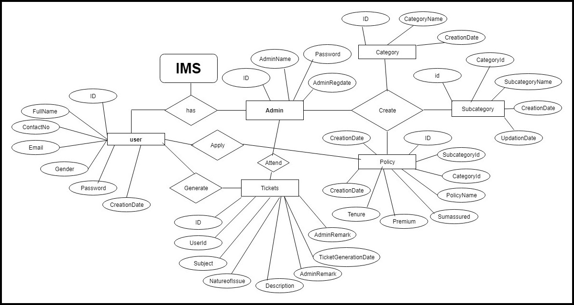

**Description:** This is an ER Diagram Insurance Management System, which shows the graphical representation that depicts relationships among Modules and their column.

## Flow Chart

Figure 11:FlowChart Diagram of Insurance Management System

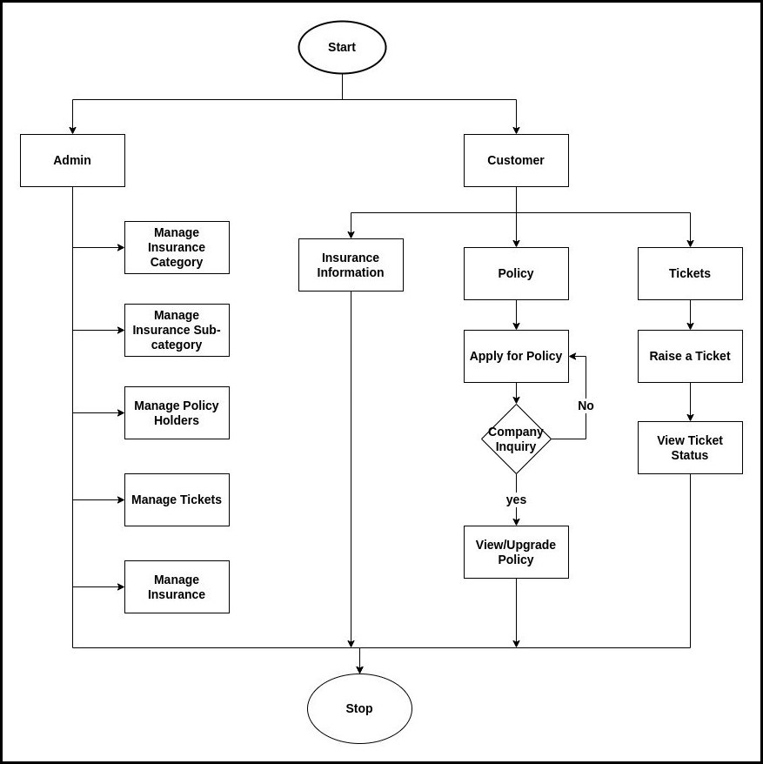

**Description:** This diagram depicts how Admin and Customer use this system by showing some steps by of Modules.

## Activity Diagram

Figure12: Activity Diagram of Insurance Management System

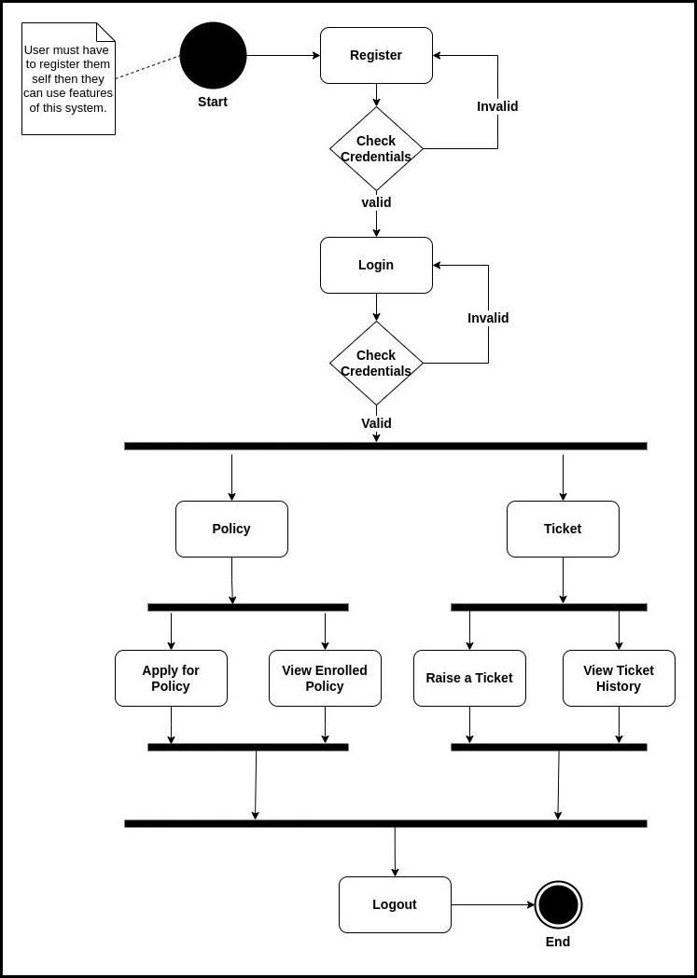

**Description:** This is an Activity Diagram Insurance Management System of Admin Side, which shows the step by step preocedure to use of every modules.

Figure13: Activity Diagram of Insurance Management System

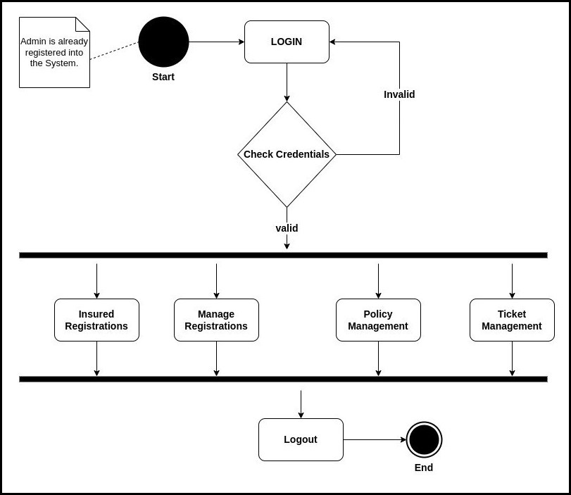

**Description:** This is an Activity Diagram Insurance Management System of User Side, which shows the step by step preocedure to use of every modules.

# Data Dictionary

**Table 1: Login Table**

**Description:** In this Table System will ask to input correct Username and Password for Login into the System, then user can take benefit of this system.

|  |  |  |  |  |  |  |
| --- | --- | --- | --- | --- | --- | --- |
| **Sr. No** | **Field Name** | **Datatype** | **Size** | **Description** | **Constraint** | **Example** |
|  | Username | varchar | 20 | Unique id of username | Primary Key | amankrs21 |
|  | Password | varchar | 20 | Password for unique id |  | ******* |

**Table 2: Registration Table**

**Description:** In this Table System will ask for some necessary data like username, password, subject, email etc. to register the user in this System.

|  |  |  |  |  |  |  |
| --- | --- | --- | --- | --- | --- | --- |
| **Sr. No** | **Field Name** | **Datatype** | **Size** | **Description** | **Constraint** | **Example** |
| 1. | Username | varchar | 20 | Username of customer | Primary Key | 23252 |
| 2. | Full Name | varchar | 20 | Name of the User |  | Aman Singh |
| 3. | Contact No | varchar | 10 | Contact Number of the User |  | 7079818064 |
| 4. | Address | varchar | 50 | Full Address of the user |  | Waghodia |
| 5. | City | varchar | 10 | Current city of the user |  | Vaodara |
| 6. | State | varchar | 10 | Current state of the user |  | Gujarat |
| 7. | Country | varchar | 10 | Current country of the user |  | India |

**Table 3: Admin Table**

**Description:** In this Table System will use these fields for Admin..

|  |  |  |  |  |  |  |
| --- | --- | --- | --- | --- | --- | --- |
| **Sr. No** | **Field Name** | **Datatype** | **Size** | **Description** | **Constraint** | **Example** |
| 1. | Admin Name | varchar | 10 | Name of the Admin |  | Admin |
| 2. | Admin Username | varchar | 10 | Username of Admin | Primary Key | admin |
| 3. | password | varchar | 20 | Password of the user |  | ****** |
| 4. | regdate | datetime |  | Date and time of admin register |  | 12-12-2022 |

**Table 4: Policy Holder Table**

**Description:** In this Table System will show the fields of policy holder of this system.

|  |  |  |  |  |  |  |
| --- | --- | --- | --- | --- | --- | --- |
| **Sr. No** | **Field Name** | **Datatype** | **Size** | **Description** | **Constraint** | **Example** |
| 1. | userid | varchar | 20 | ID of user | Foreign Key | amankrs21 |
| 2. | policyid | varchar | 20 | ID of Policy | Primary Key | RD7529BYT |
| 3. | policynumber | varhcar | 20 | Policy Number |  | 8784782647 |
| 4. | applydate | datetime |  | Apply Date Time of insurane |  | 12-12-2022 |
| 5. | policystatus | int | 1 | Status of the Policy |  | True |
| 7. | updatedate | datetime |  | Update date time of policy |  | 12-12-2022 |

**Table 5: Category Table**

**Description:** In this Table, all the information related to category of the system is shown.

|  |  |  |  |  |  |  |
| --- | --- | --- | --- | --- | --- | --- |
| **Sr. No** | **Field Name** | **Datatype** | **Size** | **Description** | **Constraint** | **Example** |
| 1. | id | int | 10 | ID of the category | Primary key | 1 |
| 2. | categoryname | varchar | 20 | Name of the category |  | Health Insurance |
| 3. | Categorydate | datetime |  | Date of category |  | 12-12-2022 |

**Table 6: Sub-Category Table**

**Description:** In this Table, all the information related to sub-category of the system is shown.

|  |  |  |  |  |  |  |
| --- | --- | --- | --- | --- | --- | --- |
| **Sr. No** | **Field Name** | **Datatype** | **Size** | **Description** | **Constraint** | **Example** |
| 1. | id | int | 10 | ID of Sub-Category | Primary Key | 1 |
| 2. | categoryid | varchar | 5 | Id of the category | Foreign Key |  |
| 3. | subcatname | varchar | 20 | Name of Subcategories |  |  |
| 3. | createdate | datetime |  | Date of Creation |  | 12-12-2022 |
| 4. | updatedate | datetime |  | Date of Updation |  | 12-12-2022 |

**Table 7: Ticket Table**

**Description:** In this Table, all the information related to Ticket of the system is shown.

|  |  |  |  |  |  |  |
| --- | --- | --- | --- | --- | --- | --- |
| **Sr. No** | **Field Name** | **Datatype** | **Size** | **Description** | **Constraint** | **Example** |
| 1. | id | int | 10 | ID of Ticket | Primary Key | 1 |
| 2. | content | varchar | 100 | Content by user |  |  |
| 3. | response | varchar | 100 | Response by Admin |  |  |
| 3. | status | boolen | 1 | Date of Creation |  | True |

# Implementation

Figure 14: Homepage

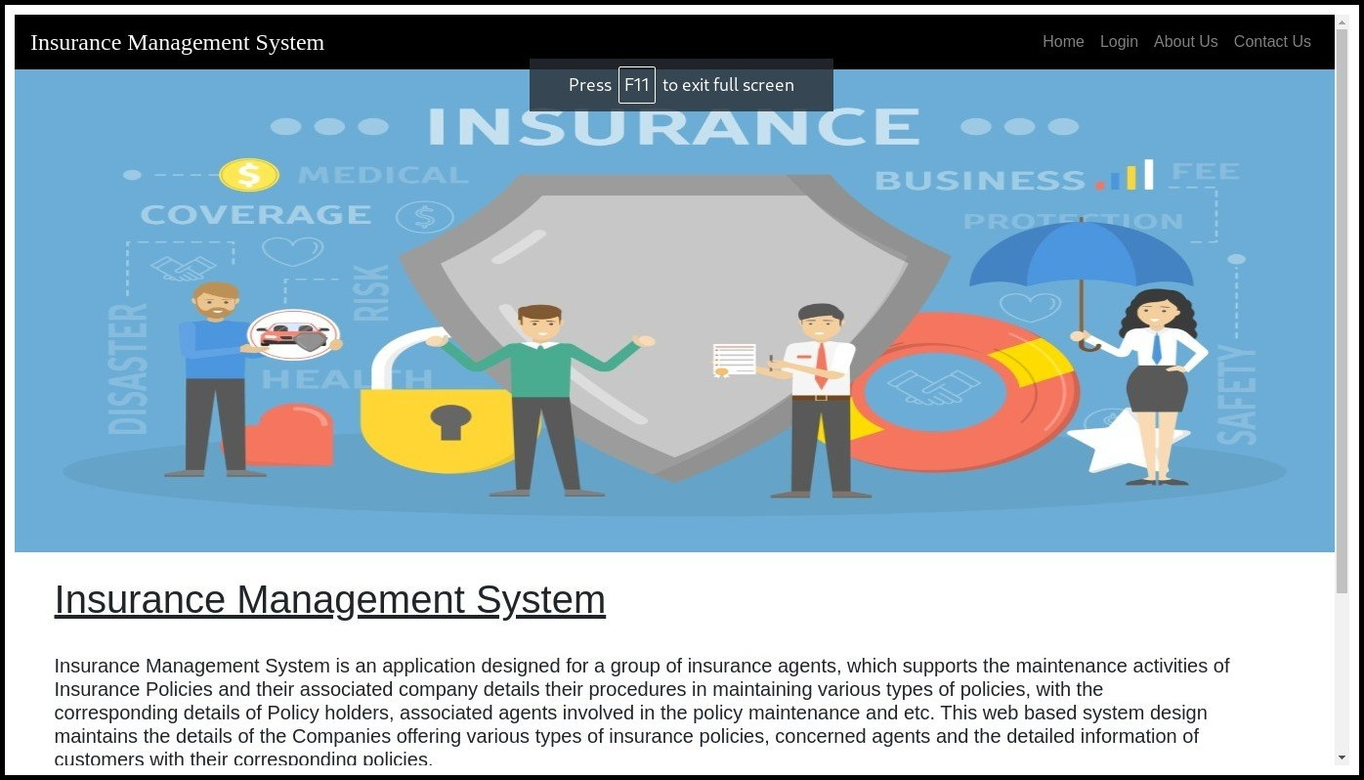

**Description :** This is the Homepage Section of our System.

Figure 15: Login

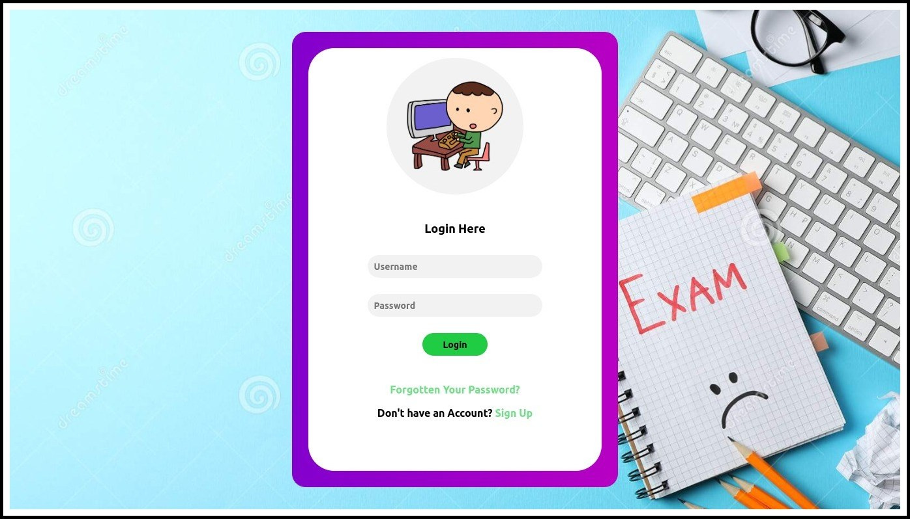

**Description :** This is the Login Page Section of our System, it will be used with both user Admin and Customer to Login into this System.

Figure16: Registration

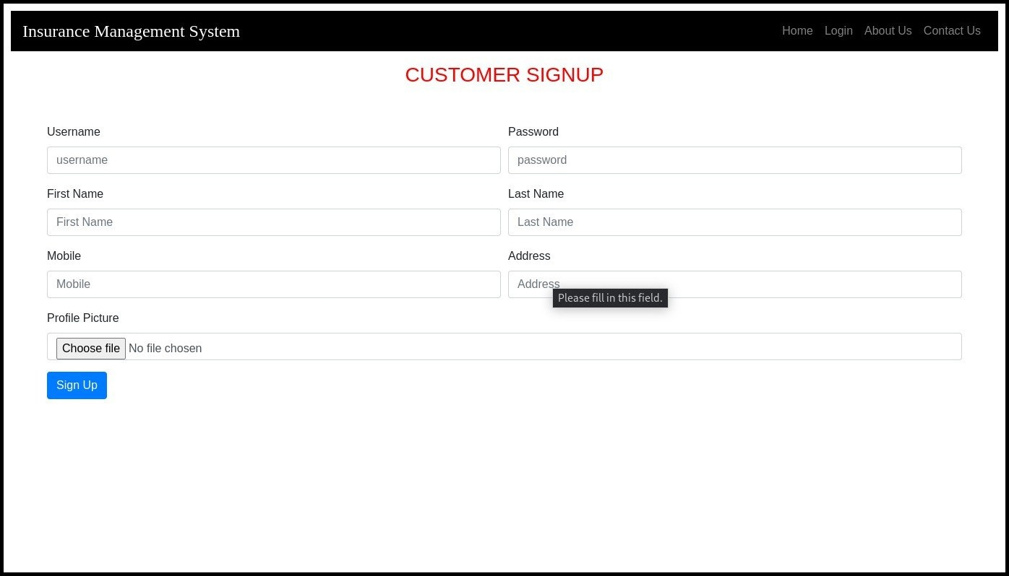

**Description :** This is the Registration Page of our System, only Customer can register themselves into this System.

Figure17: About Us

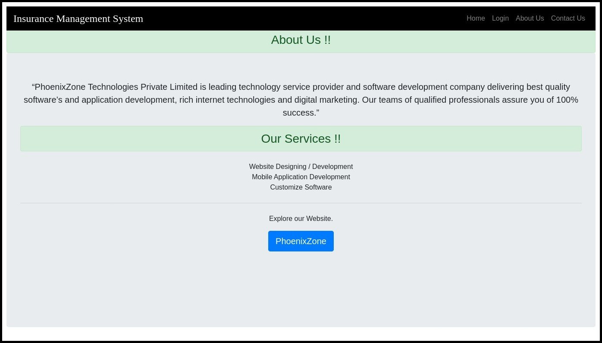

**Description :** This is the About Us section of our System.

Figure18: Admin Dashboard

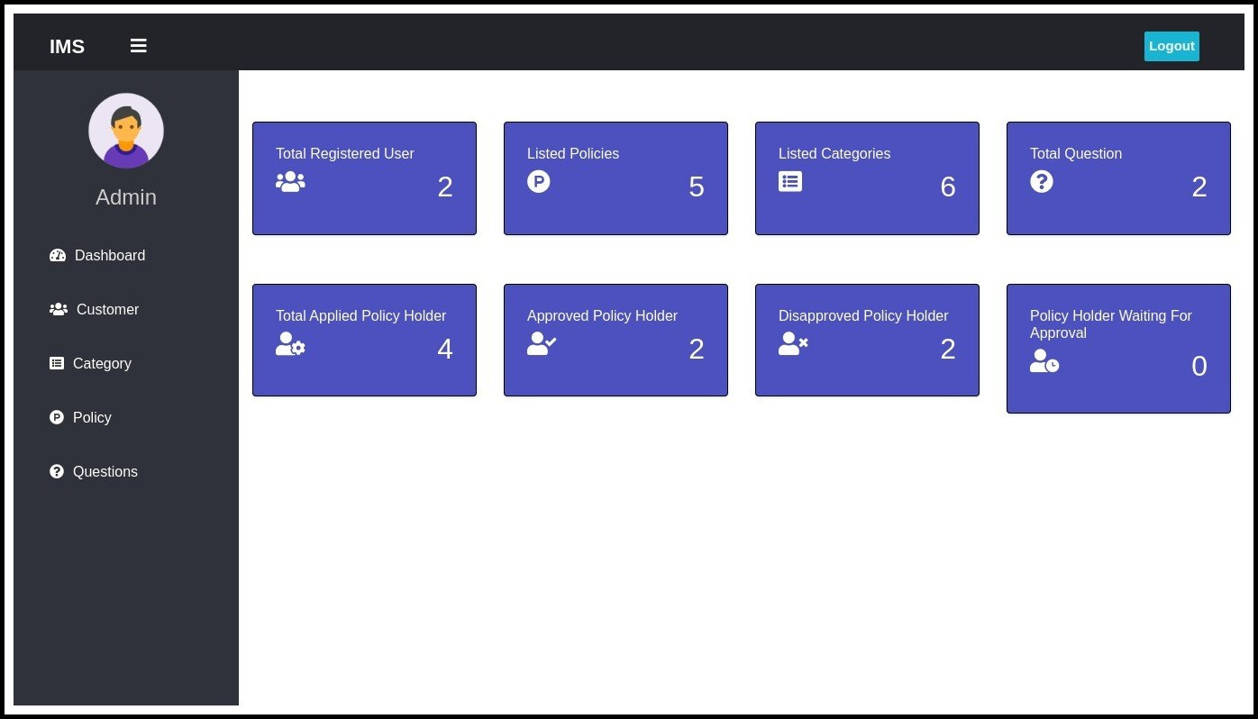

**Description :** This is the Admin Dashboard of our System.

Figure19: Customer Dashboard

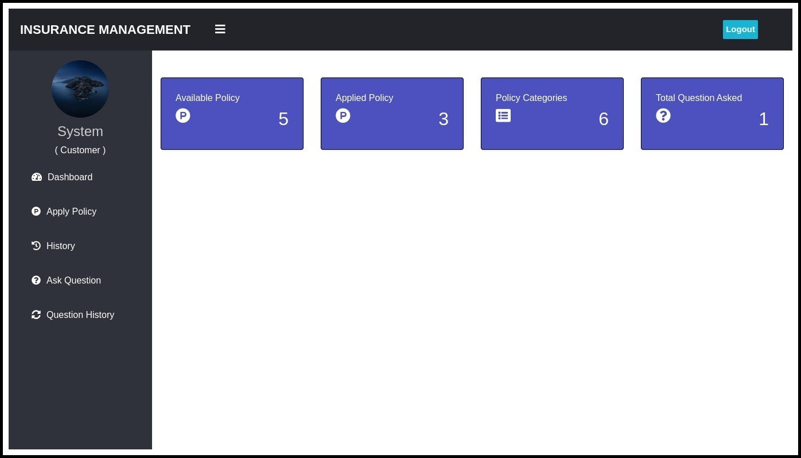

**Description :** This is the Customer Dashboard of our System.

Figure20: Add Policy

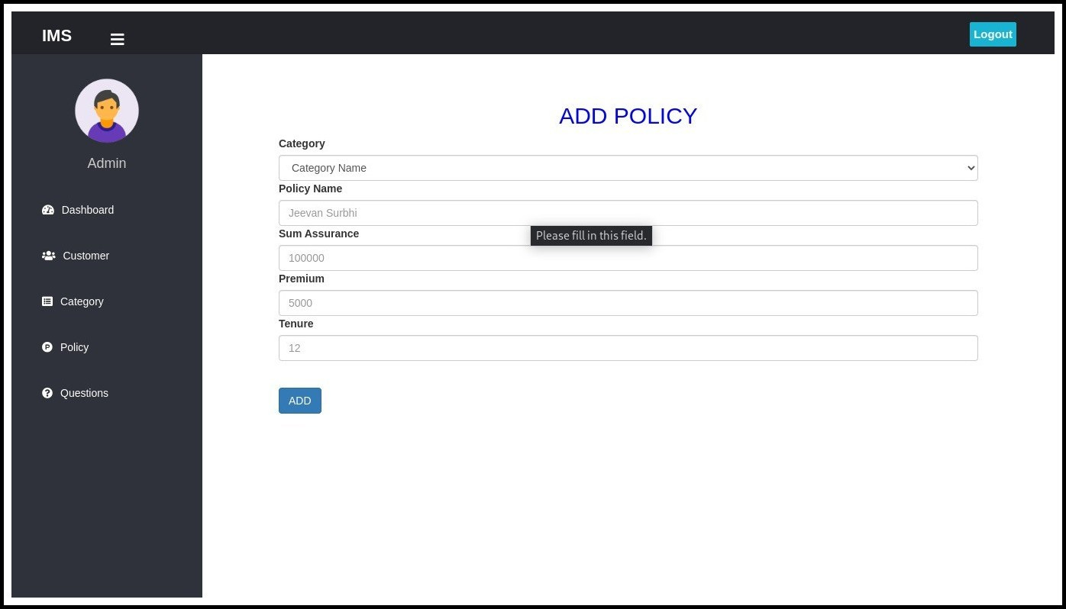

**Description :** This is the Add Policy Section of our System.

Figure21: Update Customer

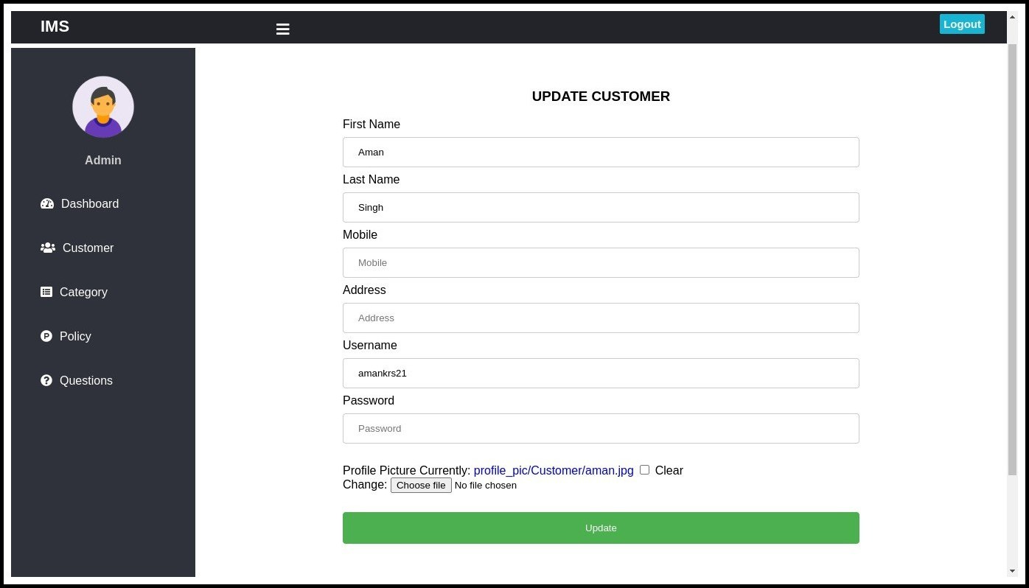

**Description :** This is the Update Customer Section of our System

Figure22: Apply for Insurance Policy

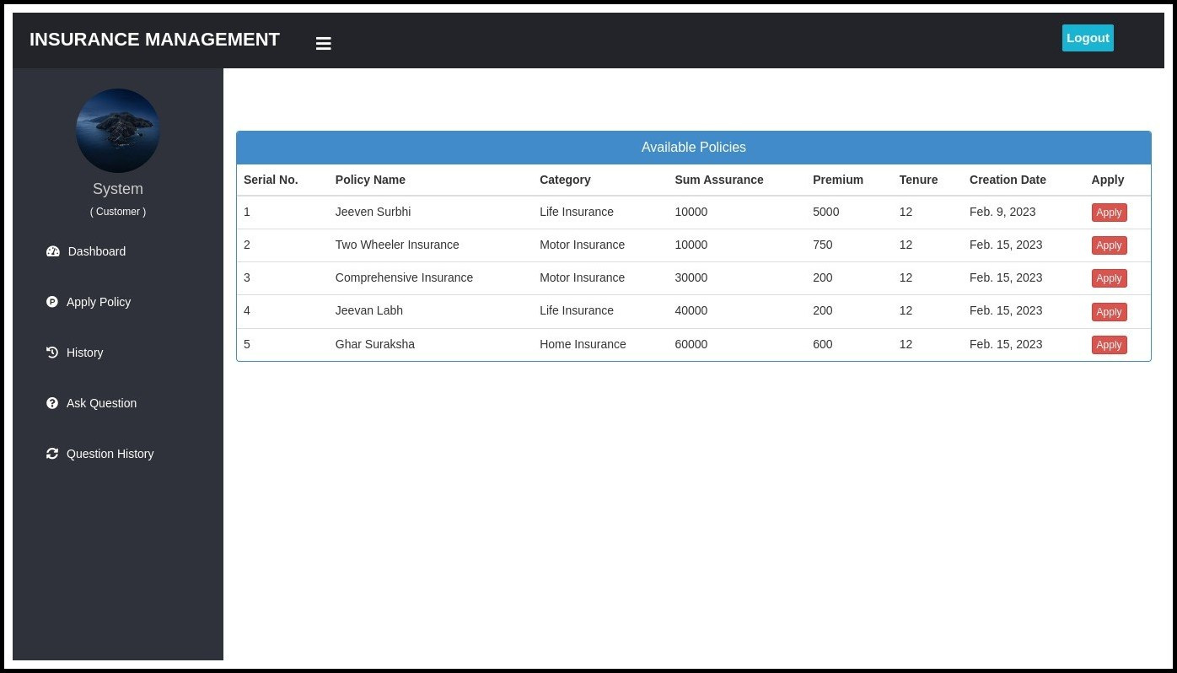

**Description :** This is the Apply for Insurance Policy section of our System, this is avaiable on Customer Side.

Figure23: View/Response Tickets

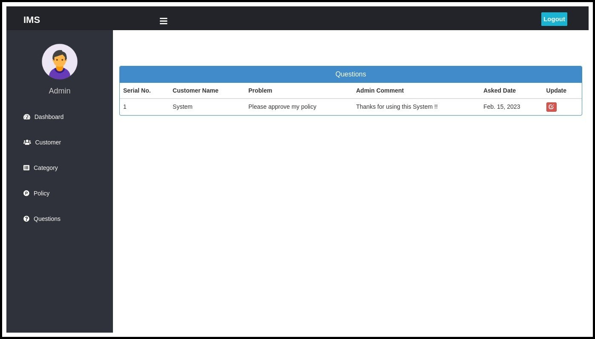

**Description :** This is the View/Response Ticket of our System, in which admin can response on Customer querries and also close the querry.

# Testing

## Test Strategy

A high-level document is used to validate the test types or levels to be executed for the product and specify the **Software Development Life Cycle's** testing approach is known as Test strategy document.

Once the test strategy has been written, we cannot modify it, and it is approved by the **Project Manager, development team.** The test strategy also specifies the following details, which are necessary while we write the test document:

* **What is the other procedure having to be used?**
* **Which module is going to be tested?**
* **Which entry and exit criteria apply?**
* **Which type of testing needs to be implemented?**

In other words, we can say that it is a document, which expresses how we go about testing the product. And the approaches can be created with the help of following aspects:

* **Automation or not**
* **Resource point of view**

We can write the test strategy based on **development design documents.**

The development design document includes the following documents:

* **System design documents:** Primarily, we will use these documents to write the test strategy.
* **Design documents:** These documents are used to specify the software's functionality to be enabled in the upcoming release.
* **Conceptual design documents:** These are the document which we used Infrequently.

## TEST CASE:

|  |  |
| --- | --- |
| **Project Name: Insurance Management System** | |
| **Test Case: Login** | |
| **Test Case ID: Rep_1** | **Test Designed by: <Aman Singh>** |
| **Test Priority (Low/Medium/High): Med** | **Test Designed date: <05-01-2023>** |
| **Module Name: login screen** | **Test Executed by: <Roshani Singh>** |
| **Test Title: Verify login with valid username and password** | **Test Execution date: <10-01-2023>** |
| **Description: Test the login page** |  |
|  |  |

|  |
| --- |
| **Pre-conditions:** User has valid username and password |
| **Dependencies:** |

|  |  |  |  |  |  |  |
| --- | --- | --- | --- | --- | --- | --- |
| **Step** | **Test Steps** | **Test Data** | **Expected Result** | **Actual Result** | **Status (Pass/Fail)** | **Notes** |
| 1 | Navigate to login page | User= [example@gmail.com](mailto:example@gmail.com) | User should be able to login | User is navigated to | Pass |  |
| 2 | Provide valid username | Password: 1234 |  | dashboard with successful |  |  |
| 3 | Provide valid password |  |  | login |  |  |
| 4 | Click on Login button |  |  |  | Pass |  |
|  |  |  |  |  |  |  |

|  |
| --- |
| **Post Conditions:** User is validated with database and successfully login to account. The account session details are logged in database. |

|  |  |
| --- | --- |
| **Project Name: Insurance Management System** | |
| **Test Case: Checking Add Policy and updated Policy list** | |
| **Test Case ID: Rep_2** | **Test Designed by: <Roshani Singh>** |
| **Test Priority (Low/Medium/High): High** | **Test Designed date: <05-01-2023>** |
| **Module Name: Policy** | **Test Executed by: <Aman Singh>** |
| **Test Title: Verify whether user able to add Policy and it shows on Policy list.** | **Test Execution date: <10-01-2023>** |
| **Description: Test the Policy Section** |  |

|  |
| --- |
| **Pre-conditions:** User should have to login in application. |
| **Dependencies:** |

|  |  |  |  |  |  |  |
| --- | --- | --- | --- | --- | --- | --- |
| **Step** | **Test Steps** | **Test Data** | **Expected Result** | **Actual Result** | **Status (Pass/Fail)** | **Notes** |
| 1 | Navigate to Web Application |  |  |  |  |  |
| 2 | Go on to Policy Sections |  |  |  |  |  |
| 3 | Fill all the required details | Jeevan Rakhsa Jeevan Rakhsa is ………….. |  |  |  |  |
| 4 | Click on Save |  | Successfully Created | Created | Pass |  |
| 5 | Check on the Policy List section |  | Updated List |  | Pass |  |

|  |
| --- |
| **Post Conditions:** User is able to add department and the new Department is Showing in the department list section. |

# Future Enhancements

* We will always try to fix bug time to time, and Improve the UI of the System which can will make this system easier to use.
* Mobile app support: The system could be enhanced by developing a mobile app for customers and/or administrators. This could provide a more convenient and user-friendly experience for users who prefer to use their mobile devices.
* Enhanced security and privacy features: The system could be enhanced by implementing more robust security and privacy features such as two-factor authentication, encryption, and compliance with industry standards and regulations.
* Artificial intelligence and machine learning: The system could be enhanced by incorporating artificial intelligence and machine learning algorithms to improve decision-making, automate certain processes, and provide more personalized experiences for users.
* Enhanced security and privacy features: The system could be enhanced by implementing more robust security and privacy features such as two-factor authentication, encryption, and compliance with industry standards and regulations.

# Reference and Bibliography

**Website:**

1. [https://in.php.net/](https://www.djangoproject.com/)
2. <https://codeigniter.com/user_guide/index.html>
3. <https://dev.mysql.com/doc/>
4. <https://github.com/>
5. <https://stackoverflow.com/>
6. <https://www.quora.com/>
7. [https://w3schools.com/](https://docs.microsoft.com/en-us)
8. <https://www.geeksforgeeks.org/>
9. <https://www.khanacademy.org/>

**Book:**

1. PHP in Advanced
2. MySQL Helping Hand
3. Company PHP Helping Guide

**Other Resources:**

1. Company Mentors
2. Some Journals
3. YouTube